ASSIGNMENT 2

The Cognos HR Scorecard: Measuring Success in Talent Management

Name: Venkatagiriraju U

NM Id: au611220104318

# **Step 1: Uploading**

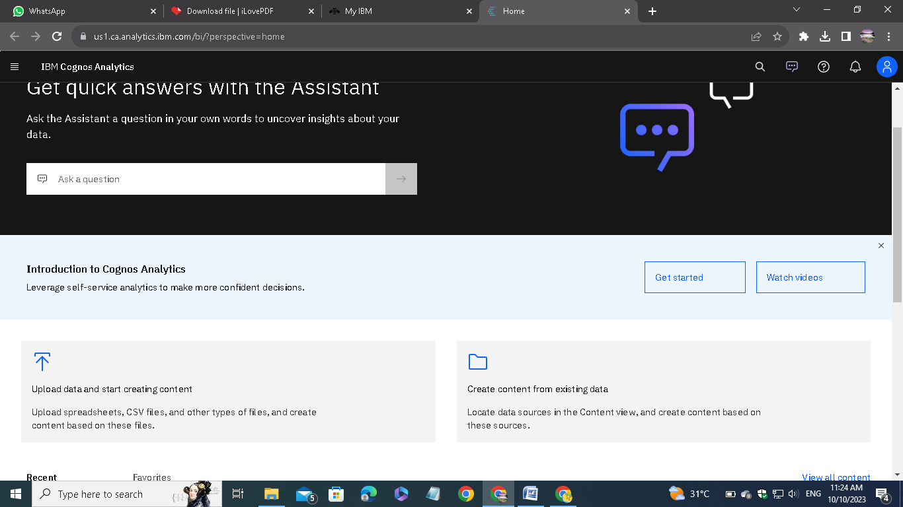

Open IBM Cognos Analytics. Then choose upload data.

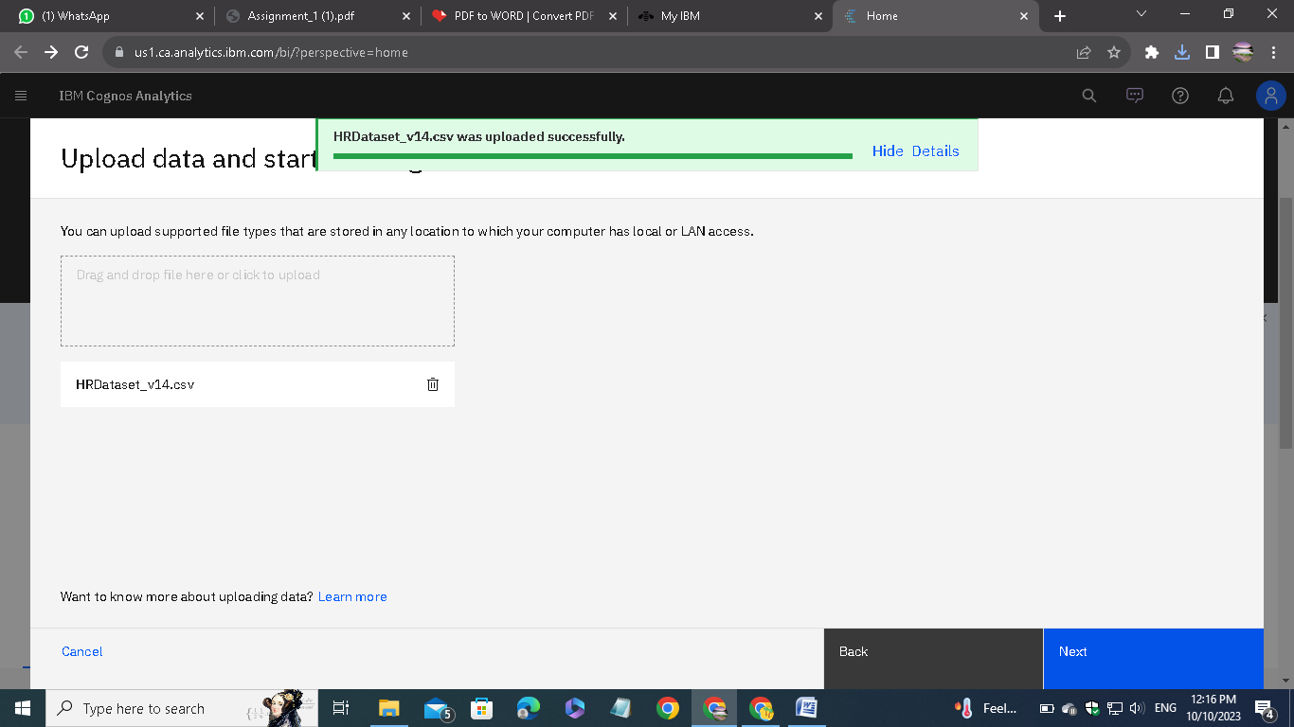

Upload the csv data file which we downloaded from the given link on the assignment.

# 

# **Step 2: Preparing**

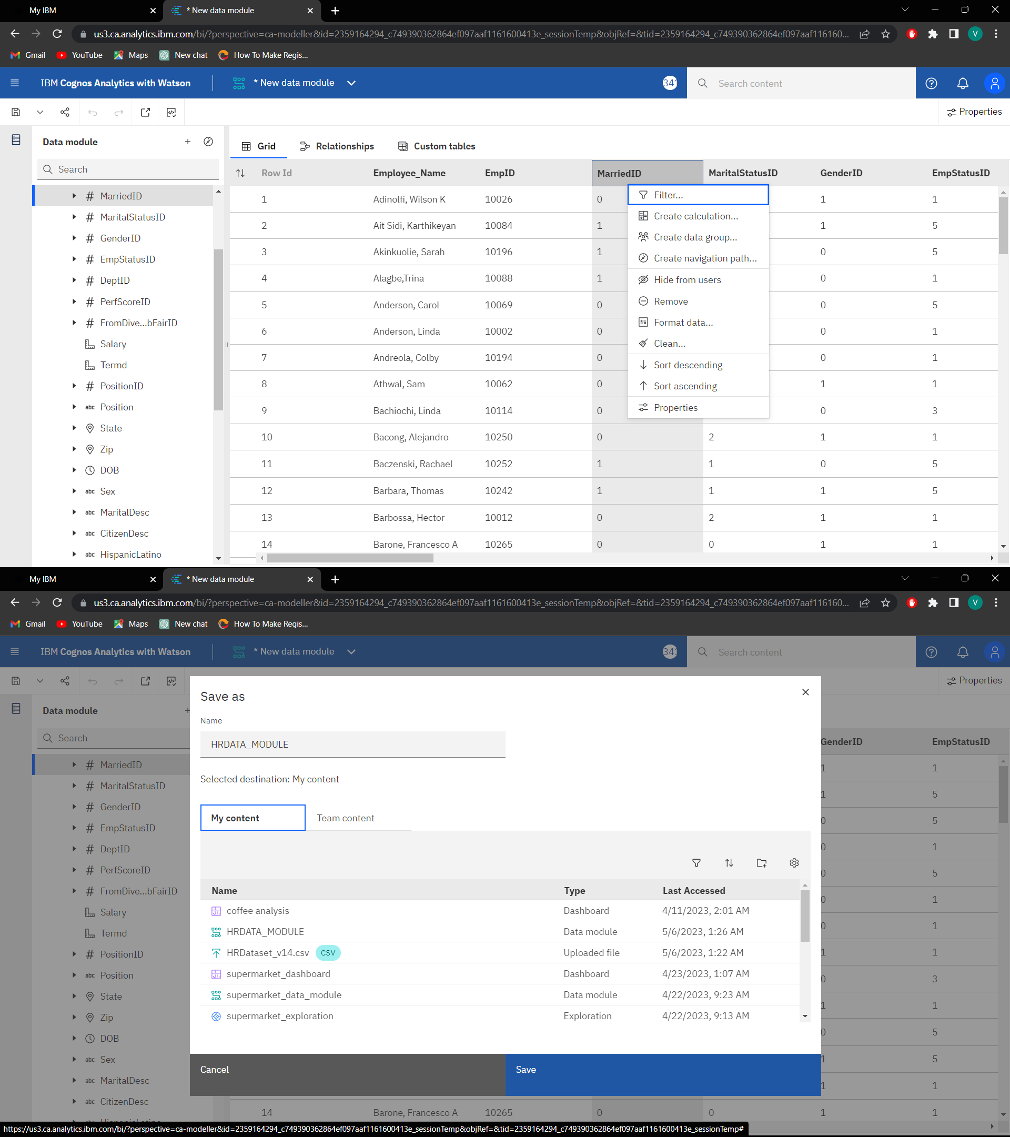

Remove the unnecessary columns and check for the missing values. In my case, there is no missing case.

After removing, save the new data module in a required name.

# **Step 3: Exploring**

# 

Go to explorations given in the menu and open the saved data module.

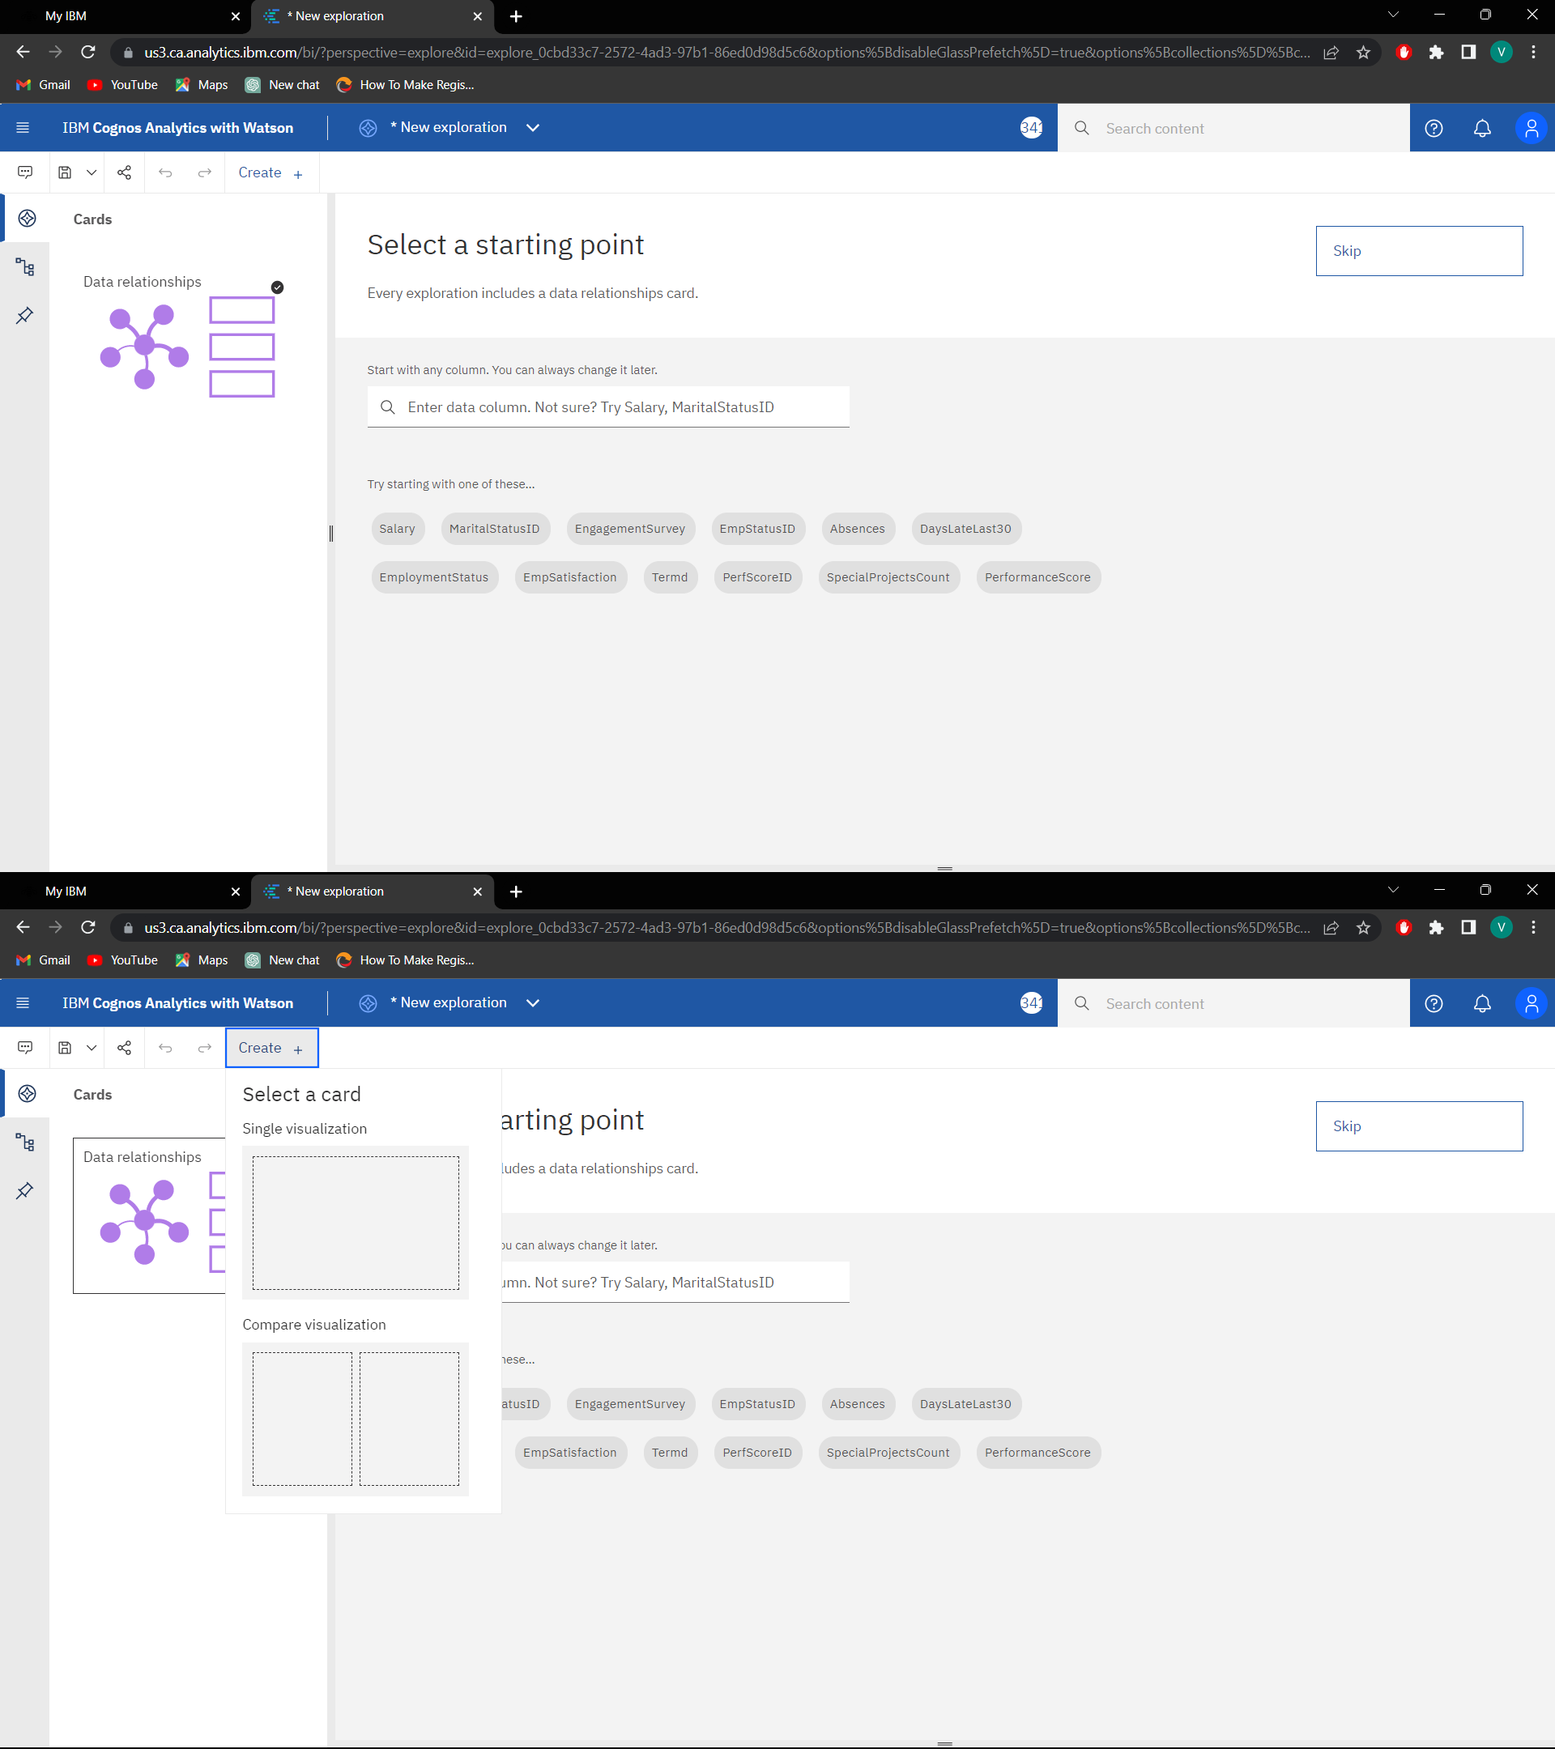



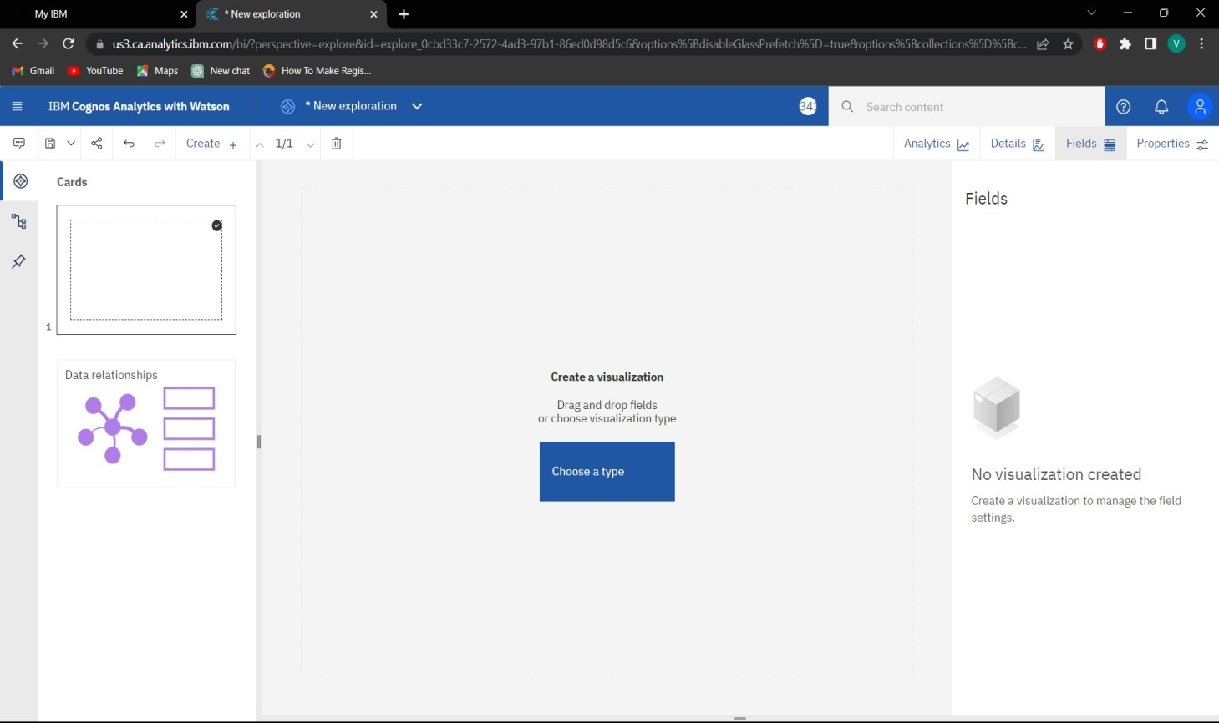

Click on create and choose the exploration style. In my case, I have chosen the single.

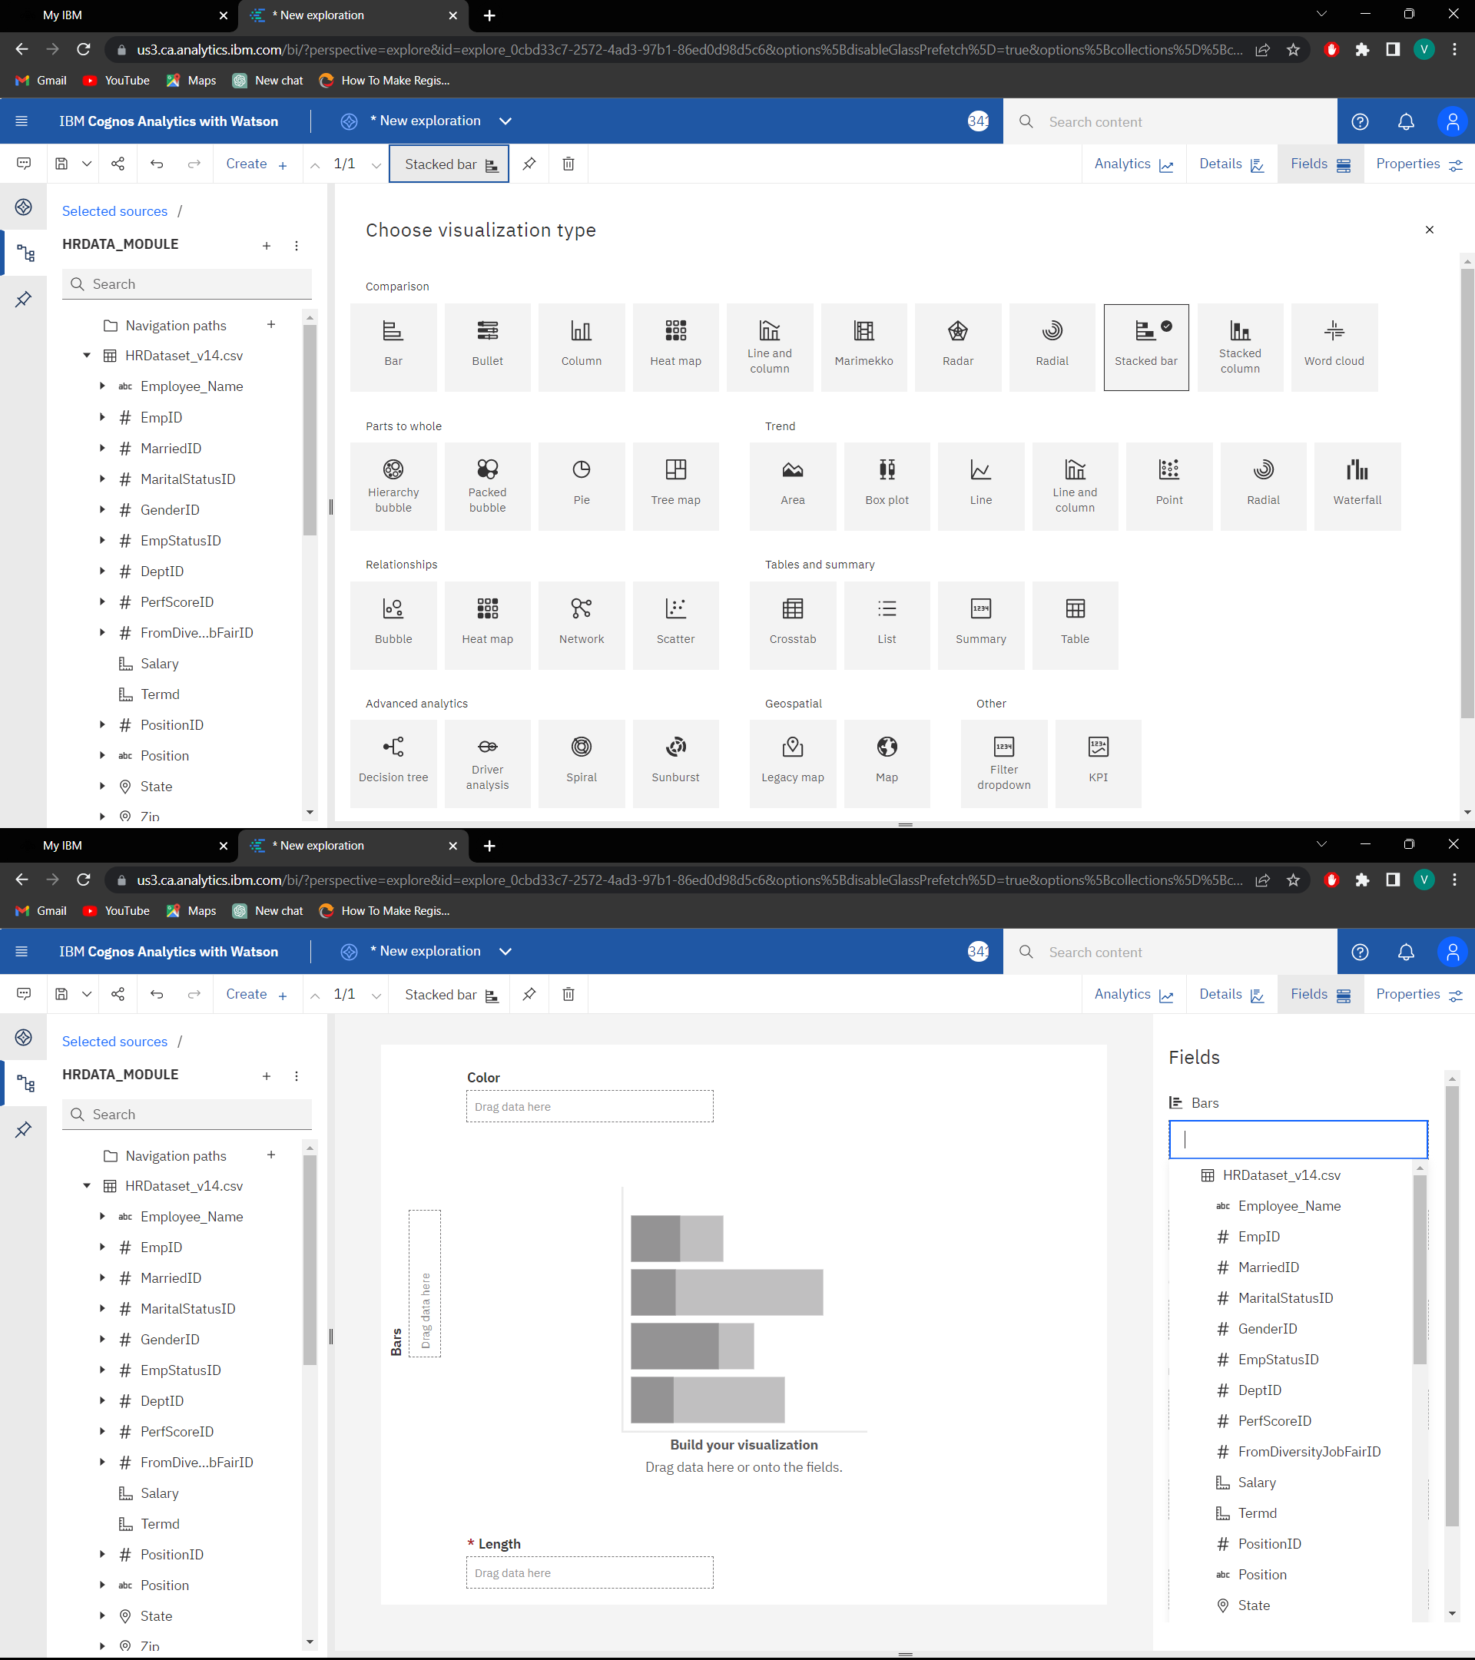



Then choose the type of the visualization. Each type of visualization is used for different needs.

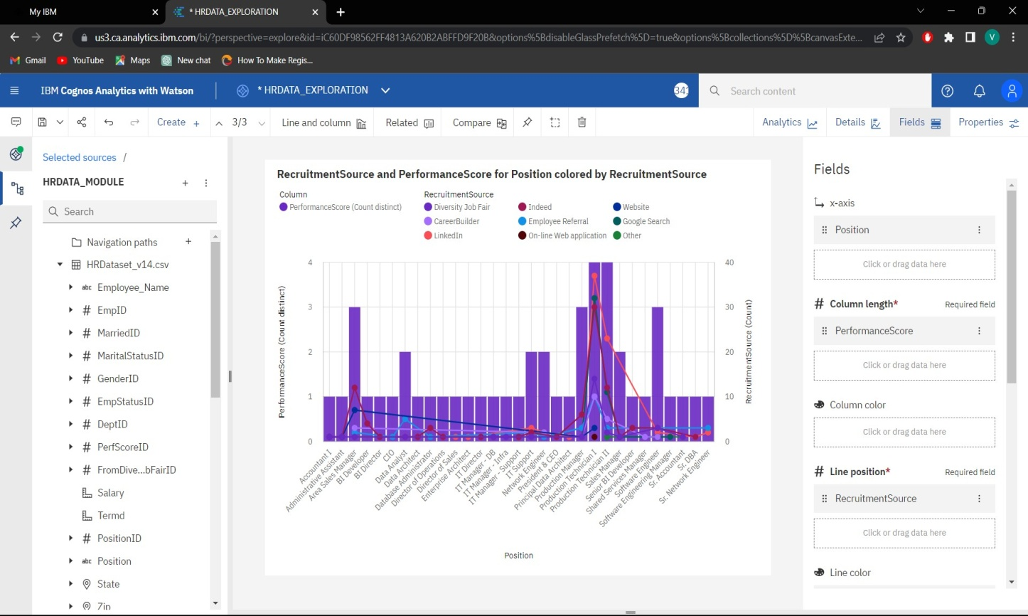

In the fields, we have to mention the attributes for the x-axis, y-axis and colors.

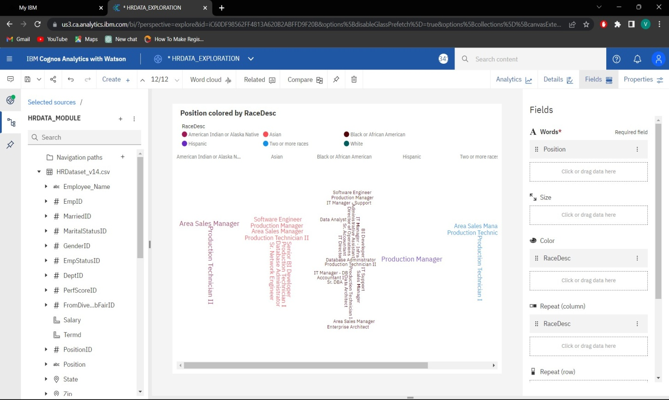

After exploring save it in a required name

# **Step 4: Dash boarding**

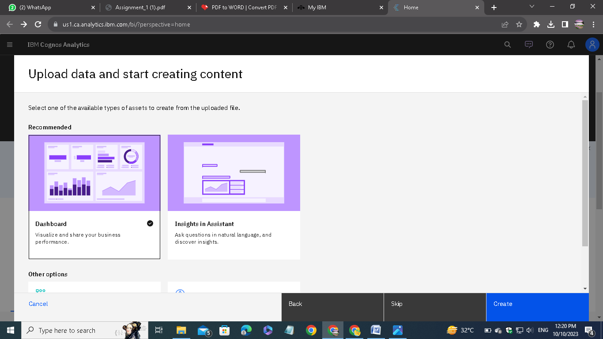

Choose the dashboard option.

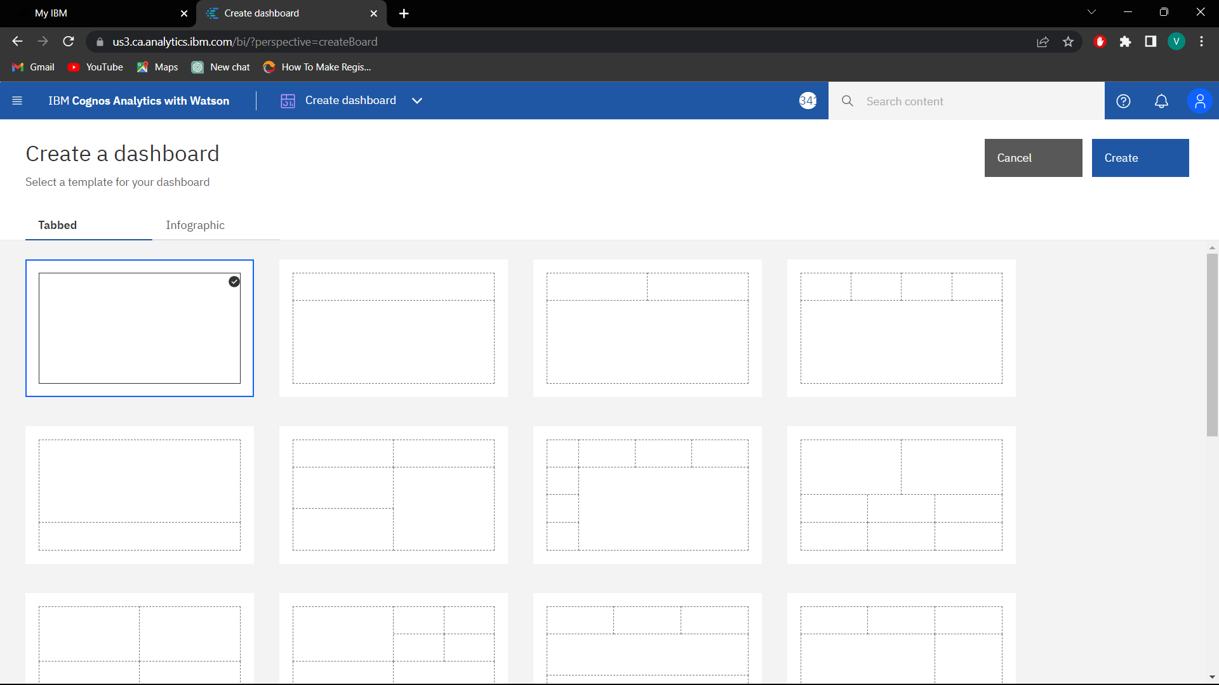

Choose the type of dashboard.

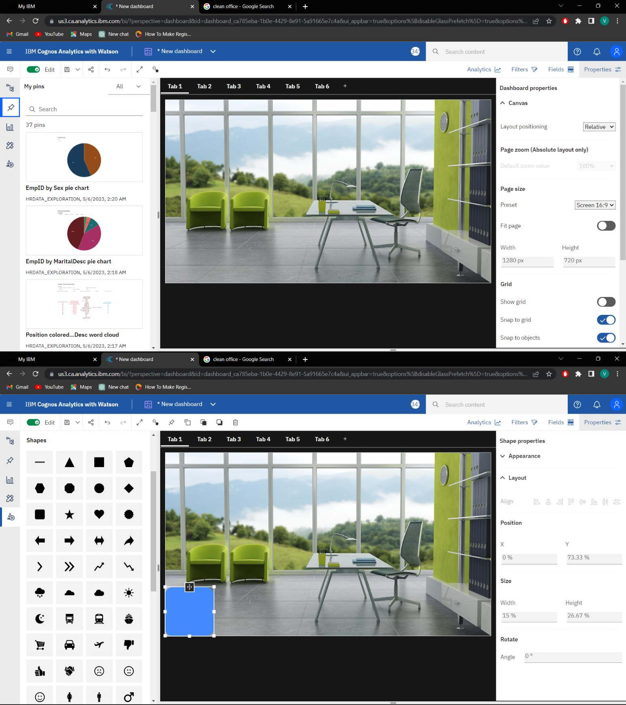

We can able to directly drag the data from the source or we can also able to plot our exploration directly from the pinned things.



After that save the presentation. These steps are followed for all other tabs. Finally we get the visualization of our analytics.

Using share option, we can able to share our presentation as direct link or the embed code.

Here I am attaching the screenshots of all the tabs I created:

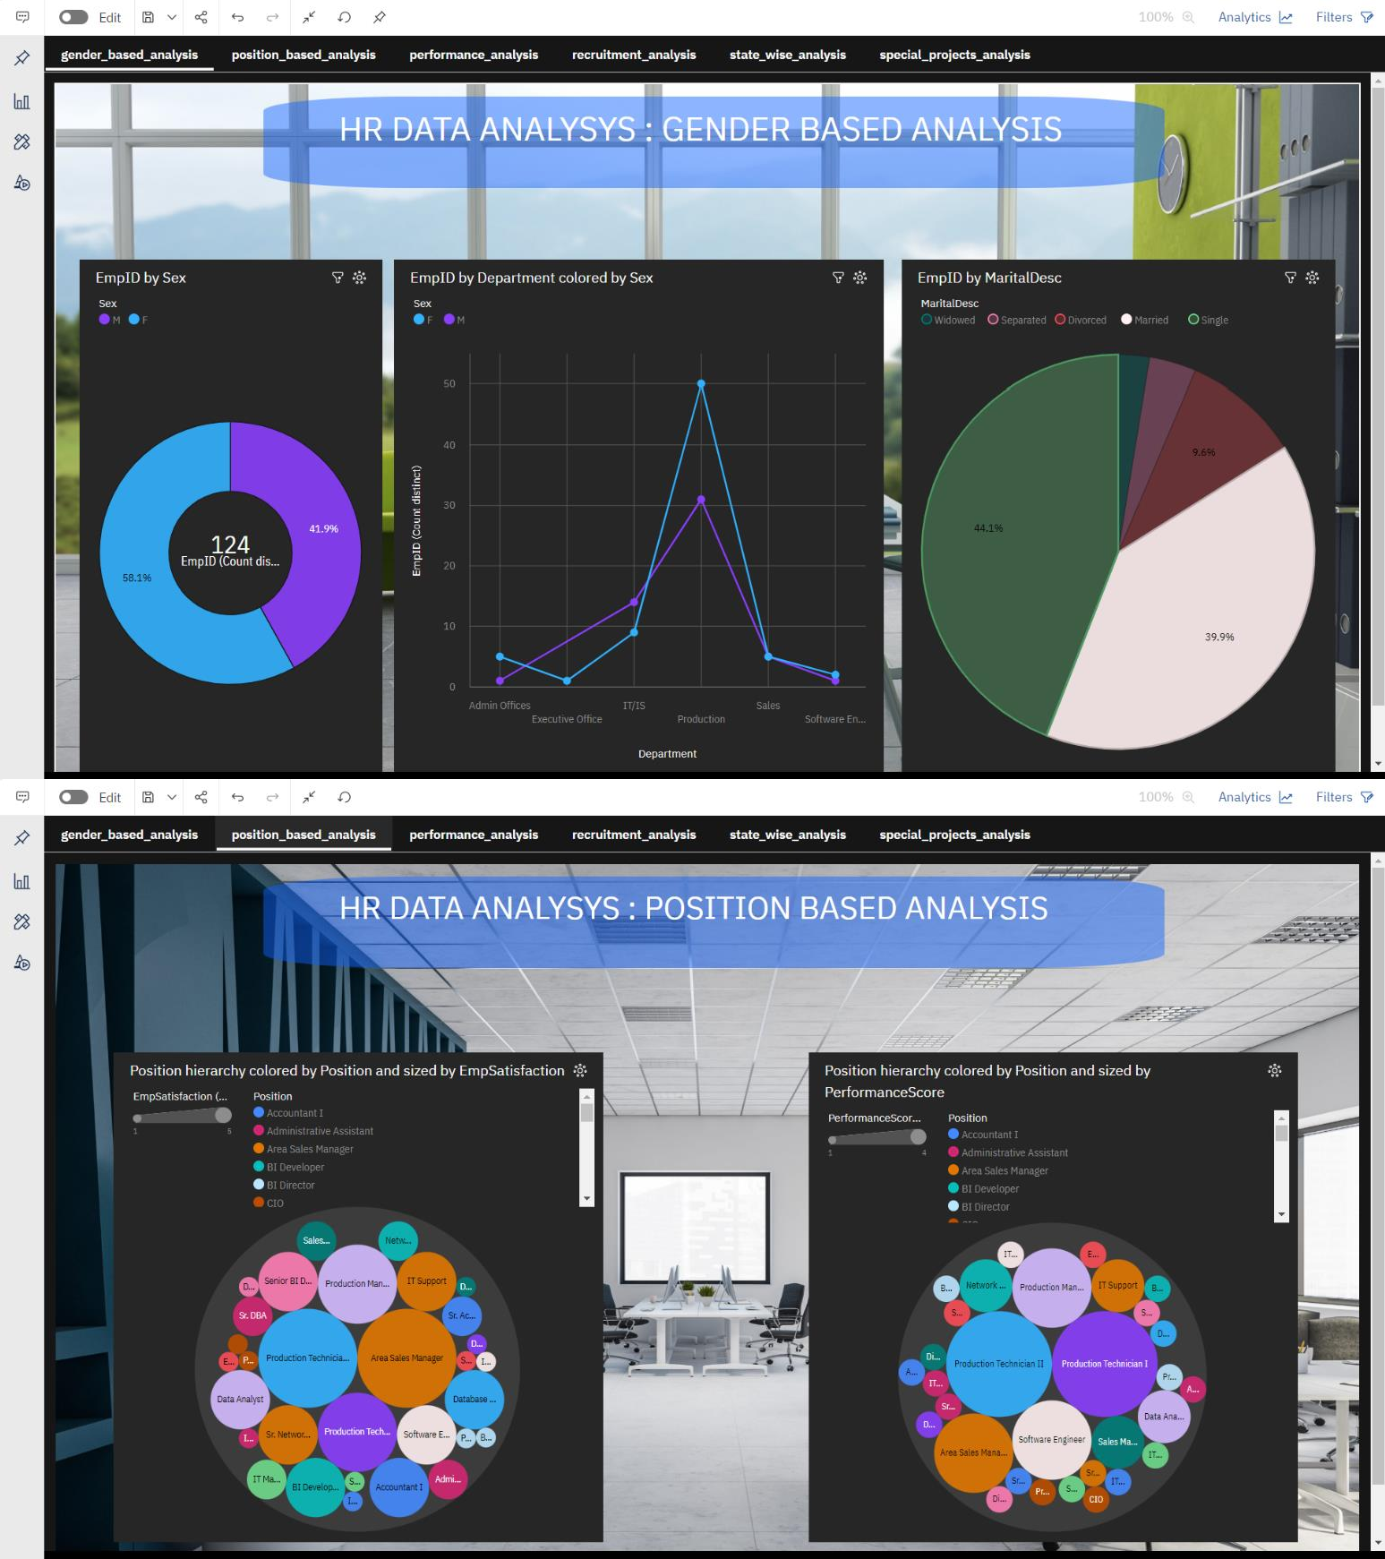

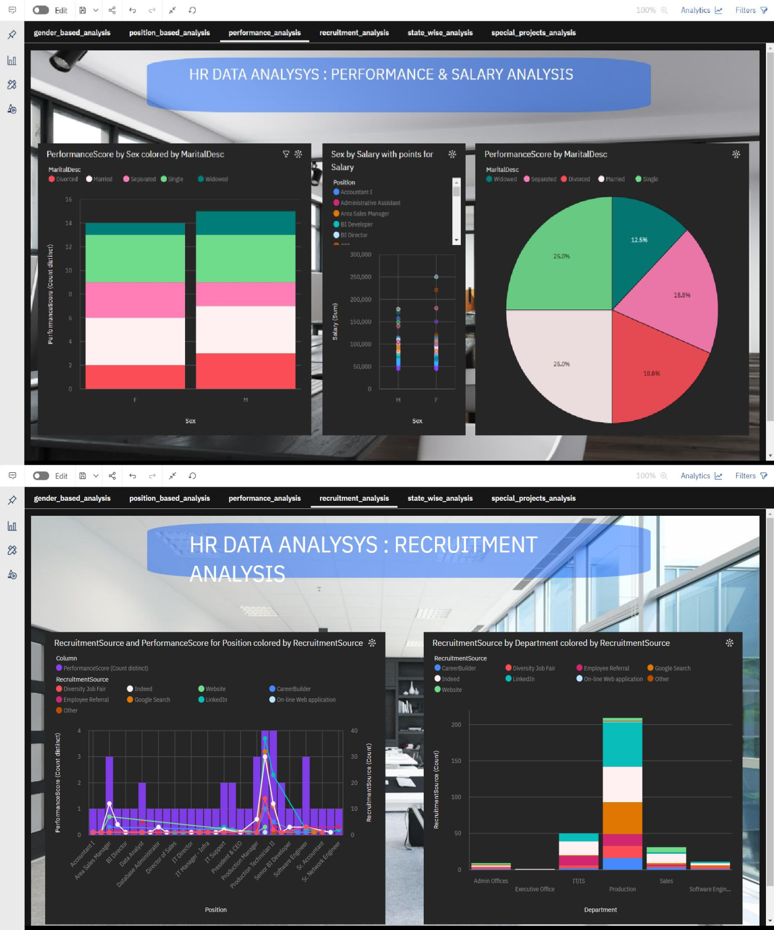

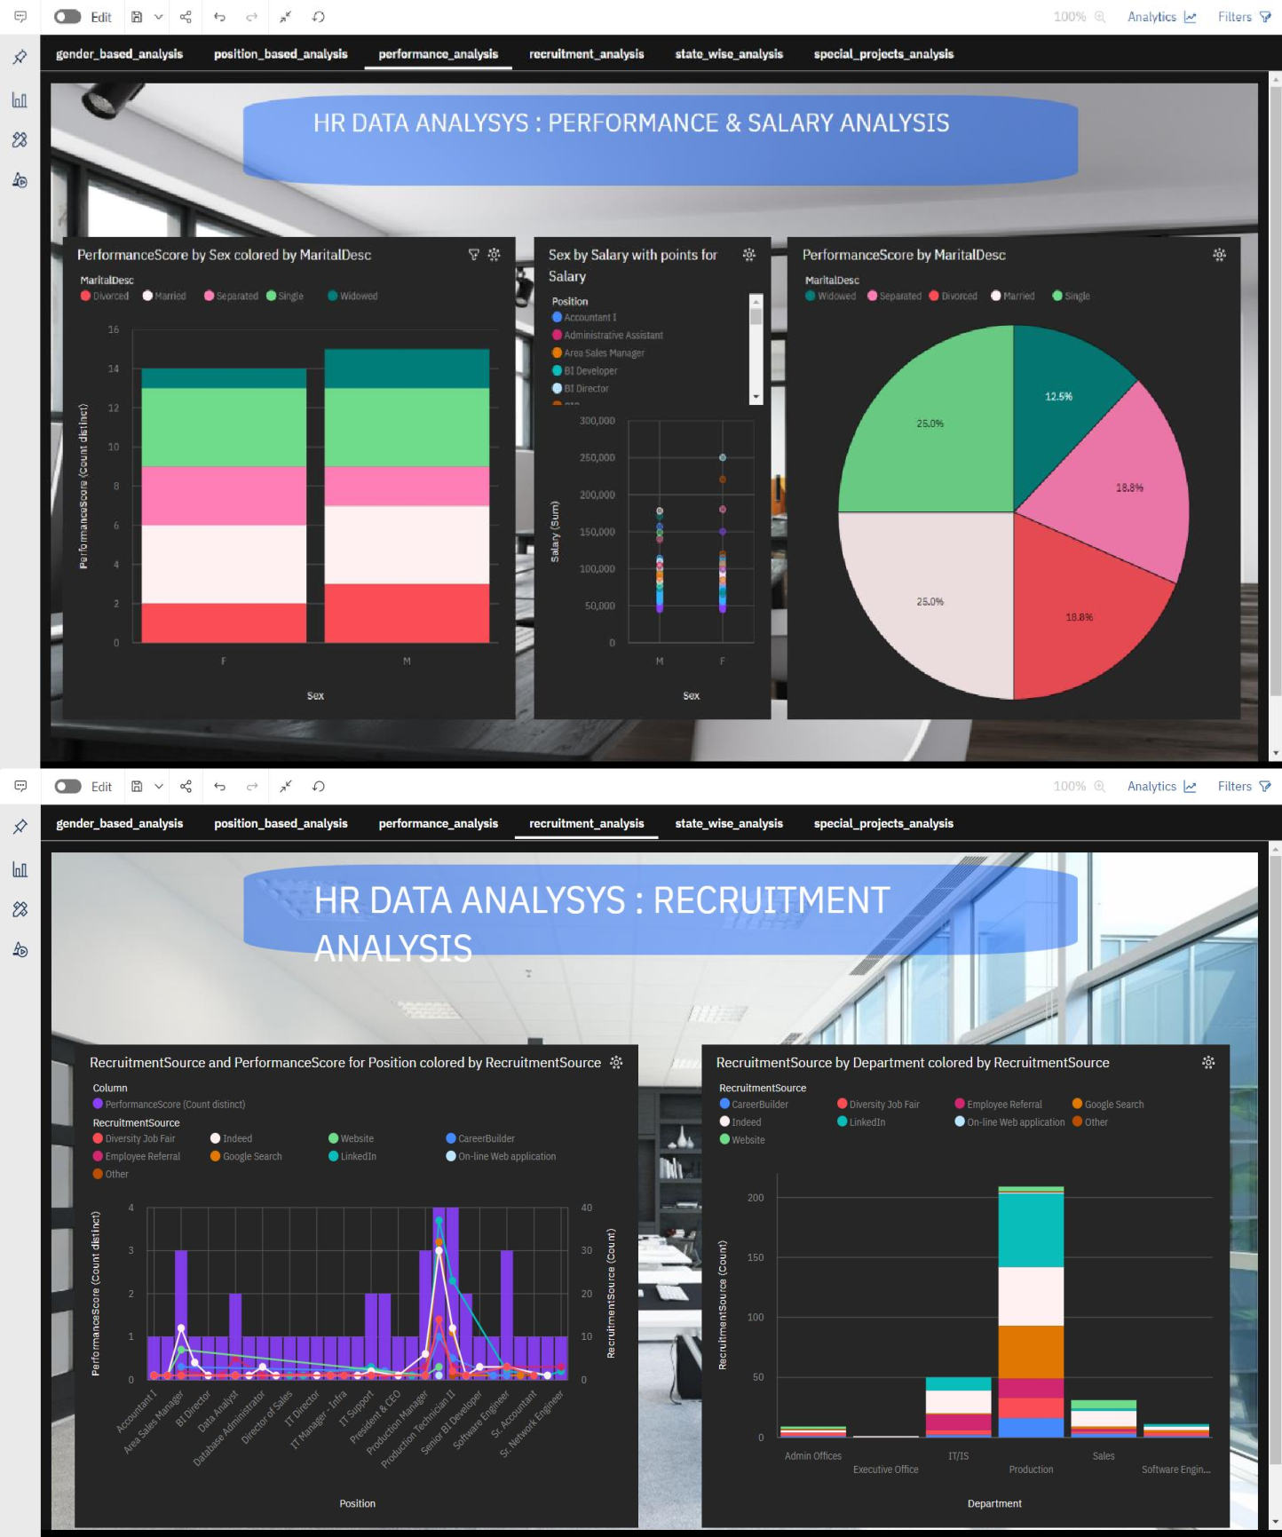

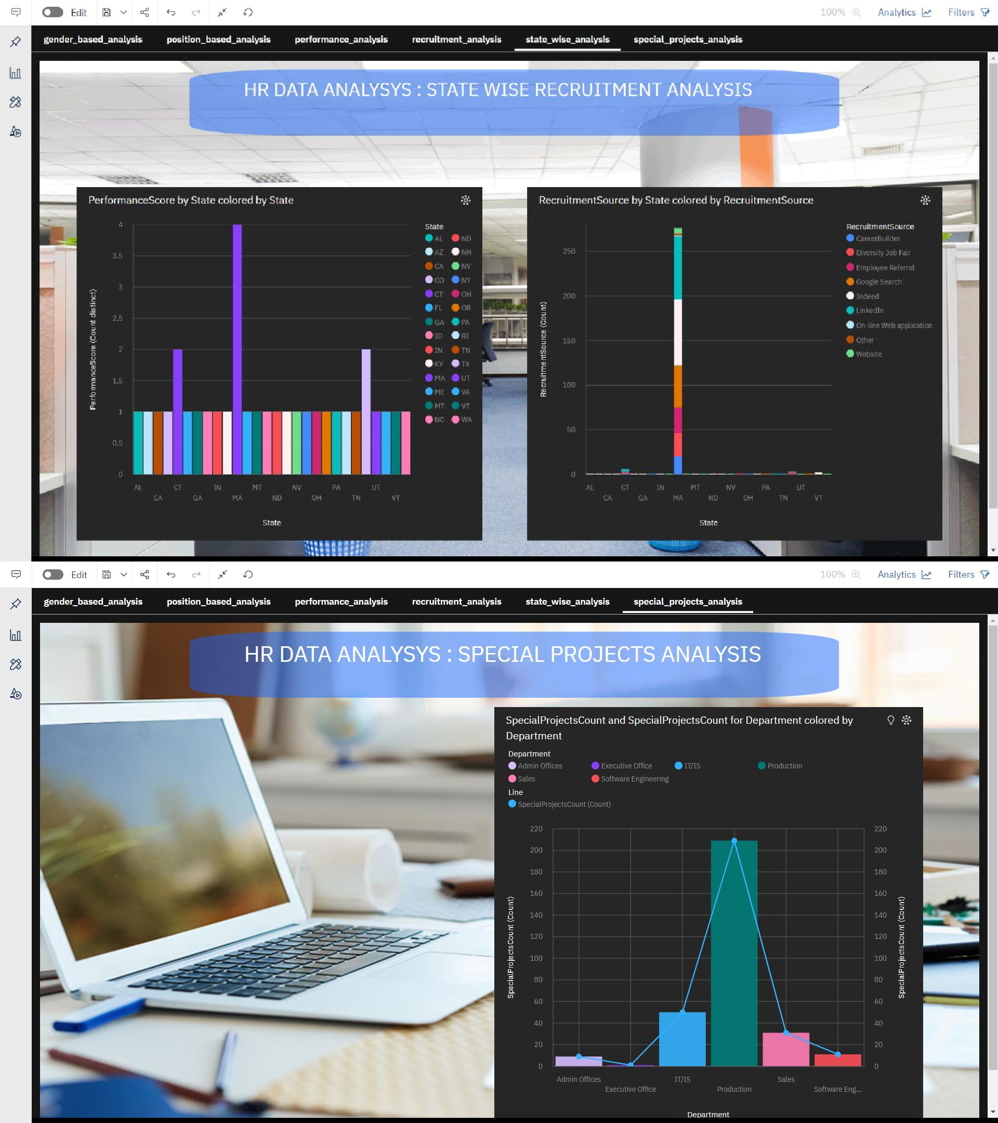



# **Step 5: Reporting**

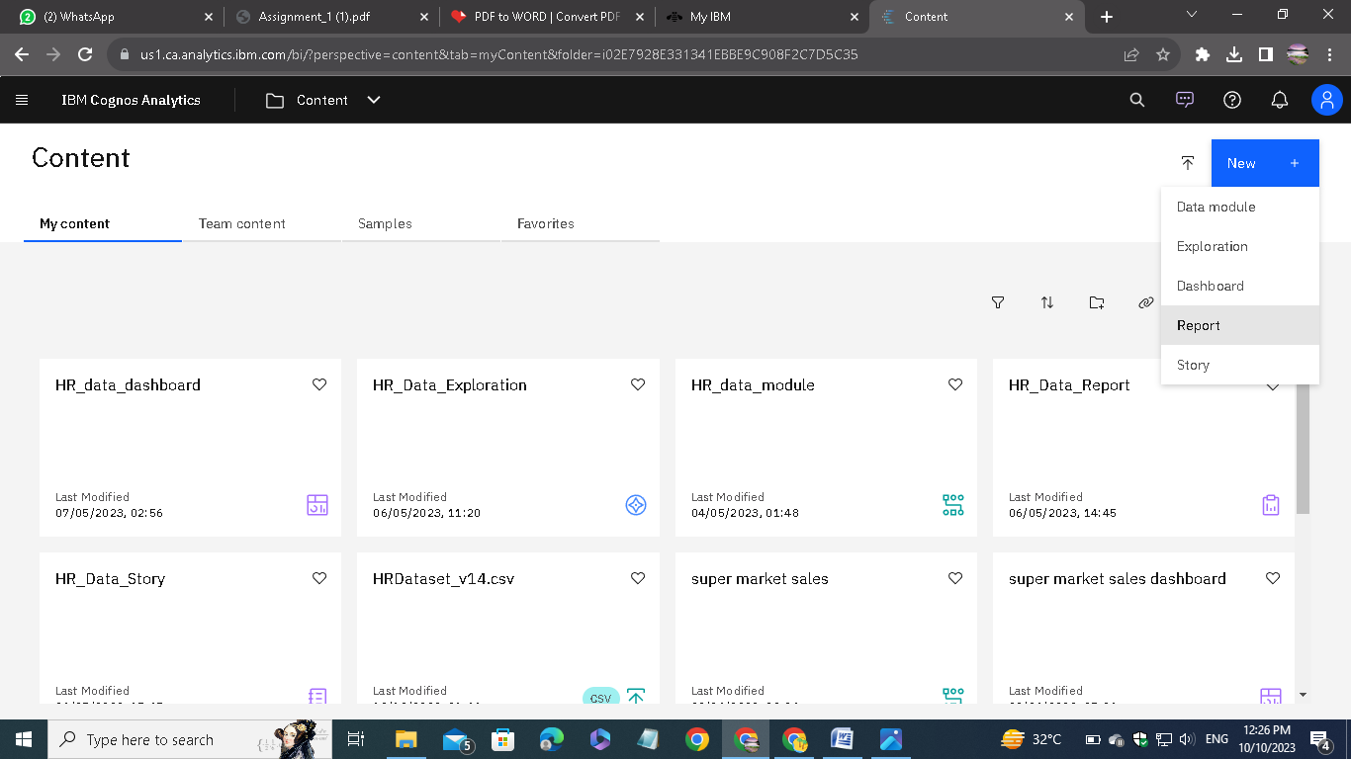

**Select the report style:**

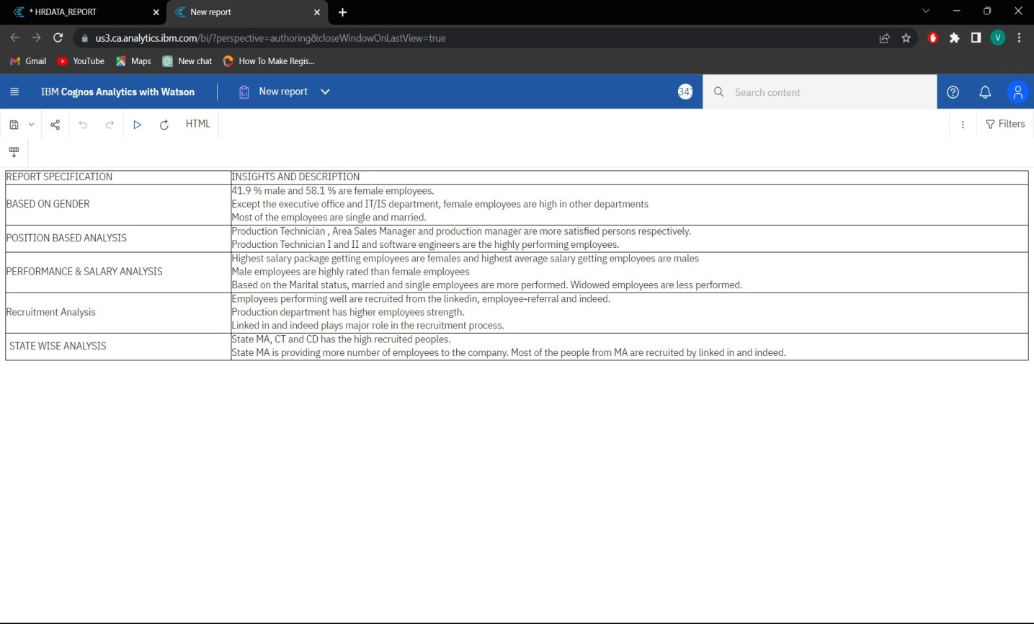

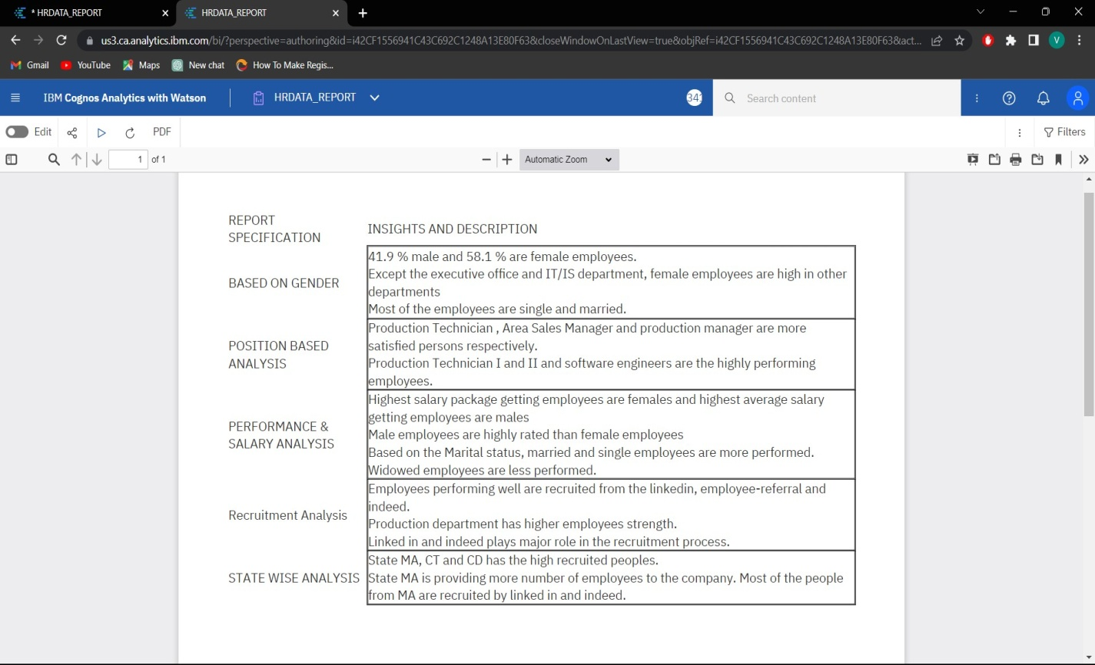

Save the report.

# **Step 6: Making story**

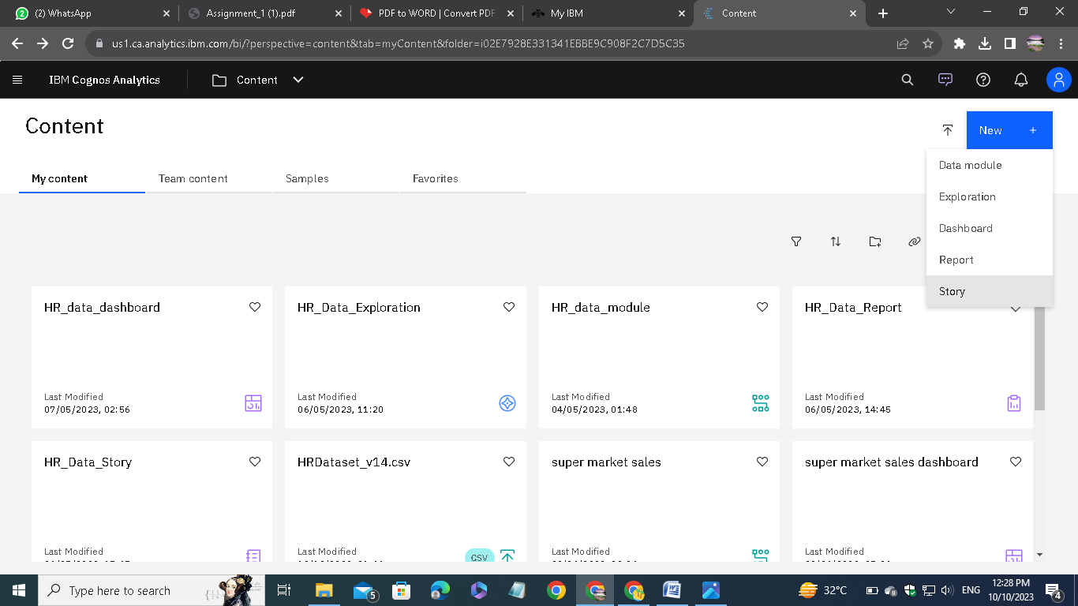

Choose story option.

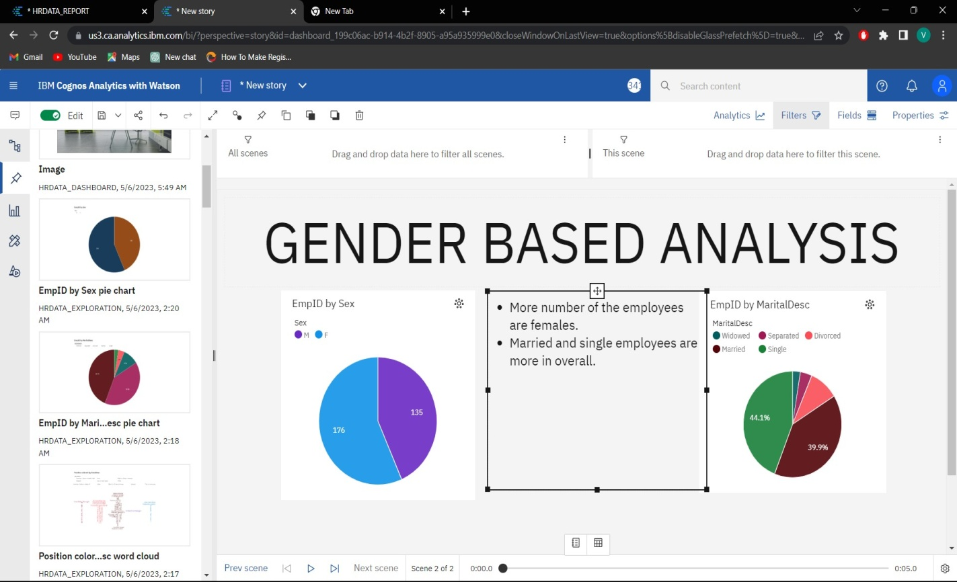

These tools are similar to the other presentation creating tools.

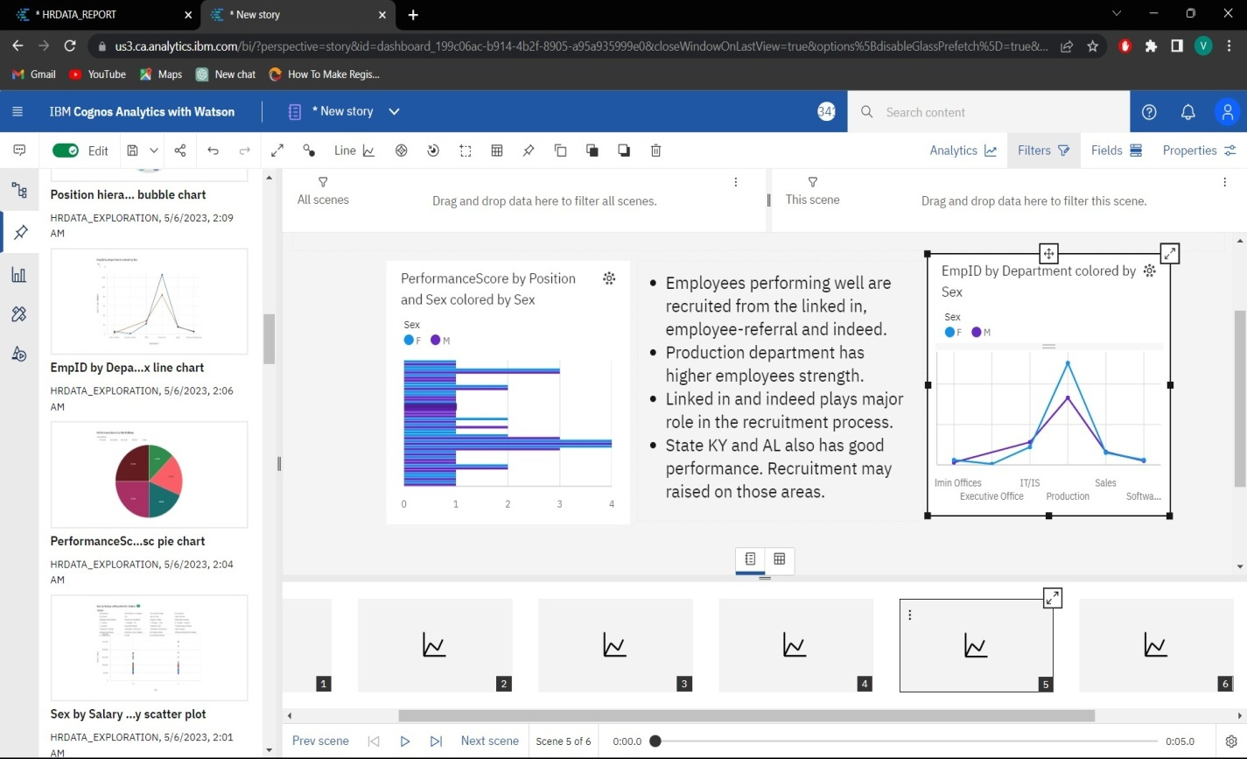

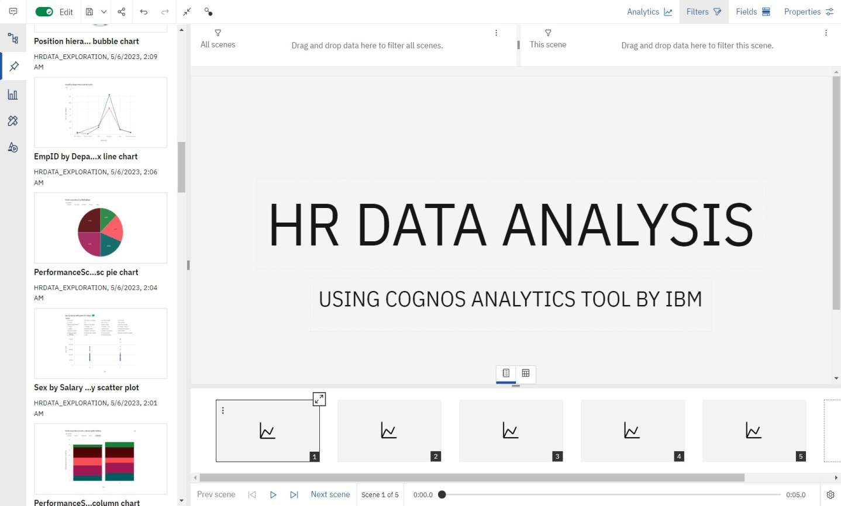

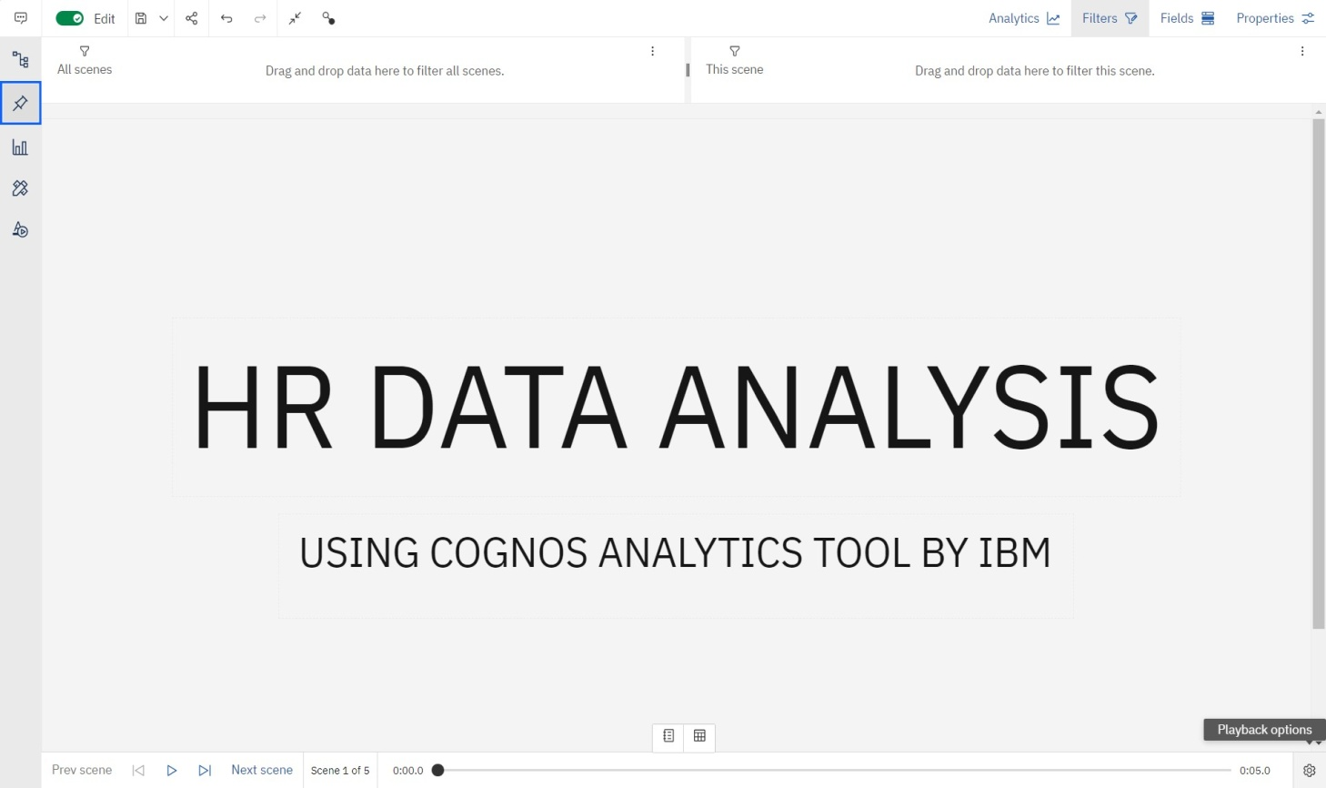Here is the completed story:

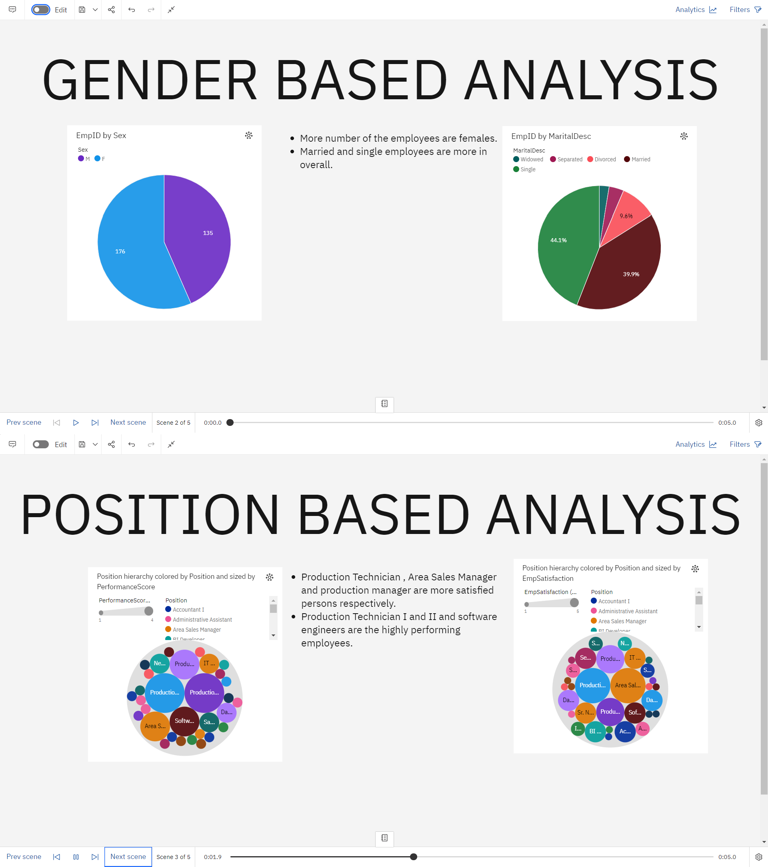

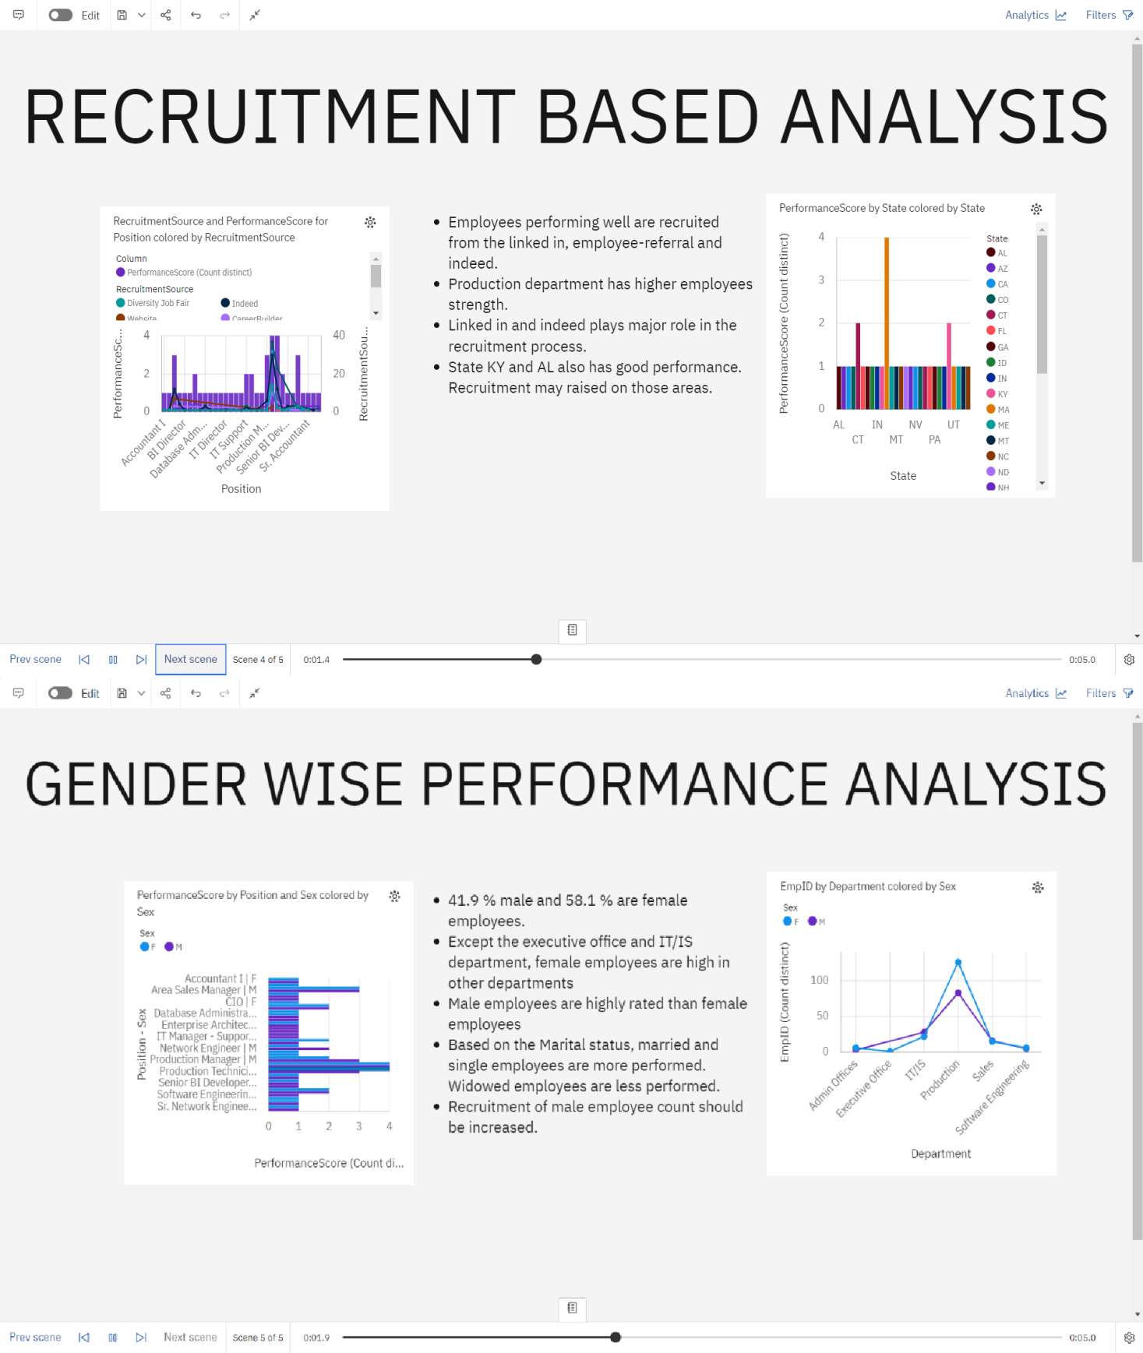

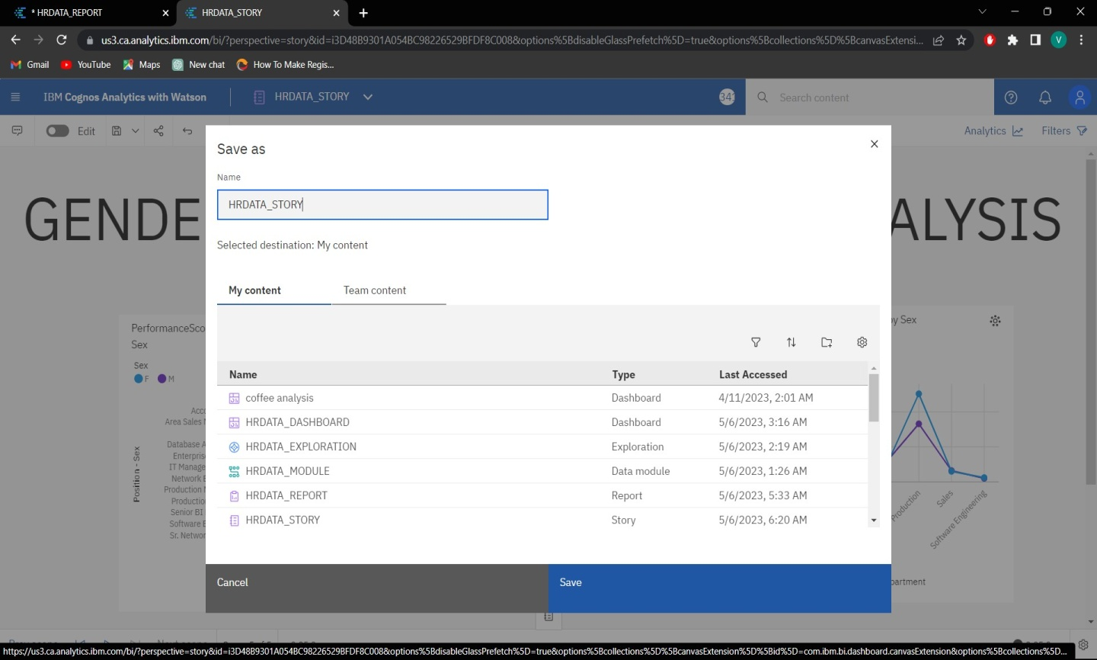

Finally save everything.